Fluid Statistics
Name
Institution Affiliations
Course Title
Date

Q6.
Density is the proportional relation between the mass of a body and the amount of volume it occupies. For example, let the mass of an element be 90g, immersed in water initially at 50cm³ volume, which increases to 59cm³ after it is immersed.
Then the volume of the material is:
V=59cm³−50cm³
V=9cm³
Density, ρ=$\frac{mass}{volume}$
ρ=$\frac{90g}{9cm3}$
ρ=10g/cm³
This density is similar to the density of Actinium from the table of chemical elements, hence the material has been identified as Actinium.
Q12.
The density of water is higher than that of ice. The density of ice in the glacier outside the lake is almost equal to the density of ice chunks in the lake, hence if their sizes are the same, they will give the same amount of additional water to the lake.
Q13.
Jogging on a soft ground wearing padded shoes reduces pressure subjected to the legs and feet since the shoes have a larger surface area which reduces the amount of pressure exerted.
Q16.
Despite that atmospheric pressure exerts a weight of about 10 tons on top of your body when lying down, you can get up because air is a fluid and it can flow in any direction and take any shape. The atmospheric air transmits the crushing force of its weight off your body frame, hence being able to get up, (Wallace and Shah, 2017).

Q24.

If the master cylinder of a hydraulic system is at a higher height than the slave cylinder, the force produced by the slave cylinder, the pressure (force) in the slave cylinder is much less than that of the master cylinder.

Q26.

When the manometer is lowered, the mercury fluid exerts less weight on the arm hence reducing the pressure measured.
When the arm is raised above the shoulder, its weight is higher, hence exerting a higher pressure on the arm.
When the cuff is placed on the upper leg with the person standing, the liquid moves until the unit weight of the liquid, and exactly stabilizes the pressure.

Q27.
Mercury is used in manometers other than water because it has a higher density, 13.6 more than that of water. This reduces the height of taking measurements hence mercury manometers are applicable for large pressures such as blood pressure, (Behi, 2018).
Q31.
When marbles are dropped to the bottom of a partially filled bathtub sink, the downward force on the foot of the tub increases equally as the weight of the marbles because the buoyant force is the same as the weight of the object according to Archimedes’ principle.
Q37.
Capillary action can be used in moving fluids in weightless environments since there is a lack of gravity in the orbiting space, hence no force to stop the capillary action.
Q38.
The effect of capillary action on the manometer having uniform diameter causes a concave or convex meniscus. At the point when the fluid is in the capillary tube, contingent upon the angle it makes with the surface, that is the edge of contact, we can have either concave meniscus, convex meniscus, or no meniscus. In concave meniscus, the fluid will ascend in the slender cylinder. In convex meniscus, the fluid will tumble down. This error in perusing because of the meniscus is considered as a manual mistake which prompts little error in pressure estimation whereas, in no meniscus fluid, the perusing doesn't get an error in height, (Levy, 2018).
Q6.
To identify the substances you need to determine the density of each material, total mass or volume, and mass of one material.

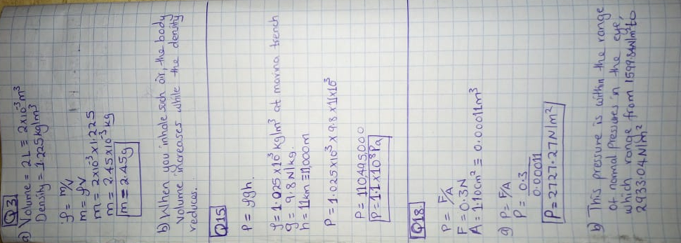

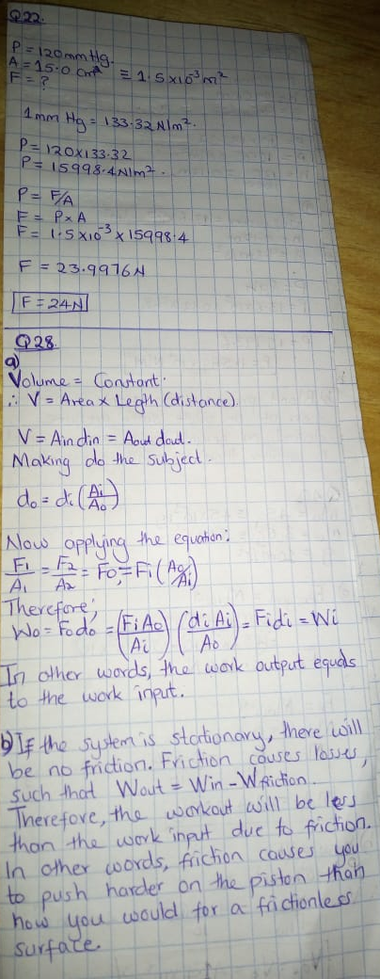

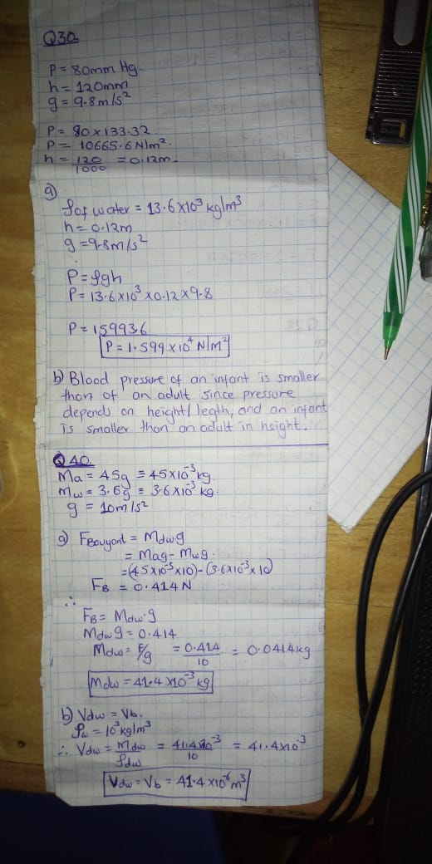

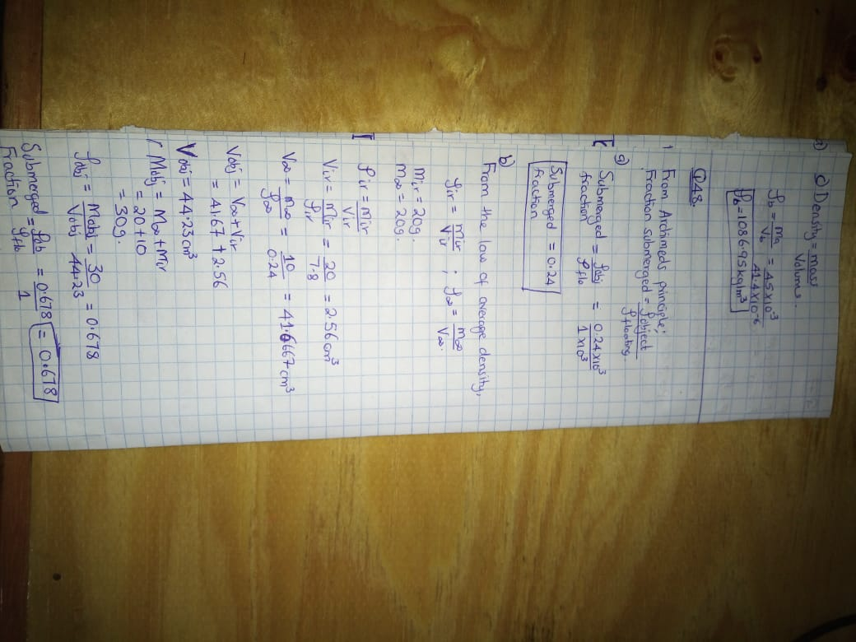
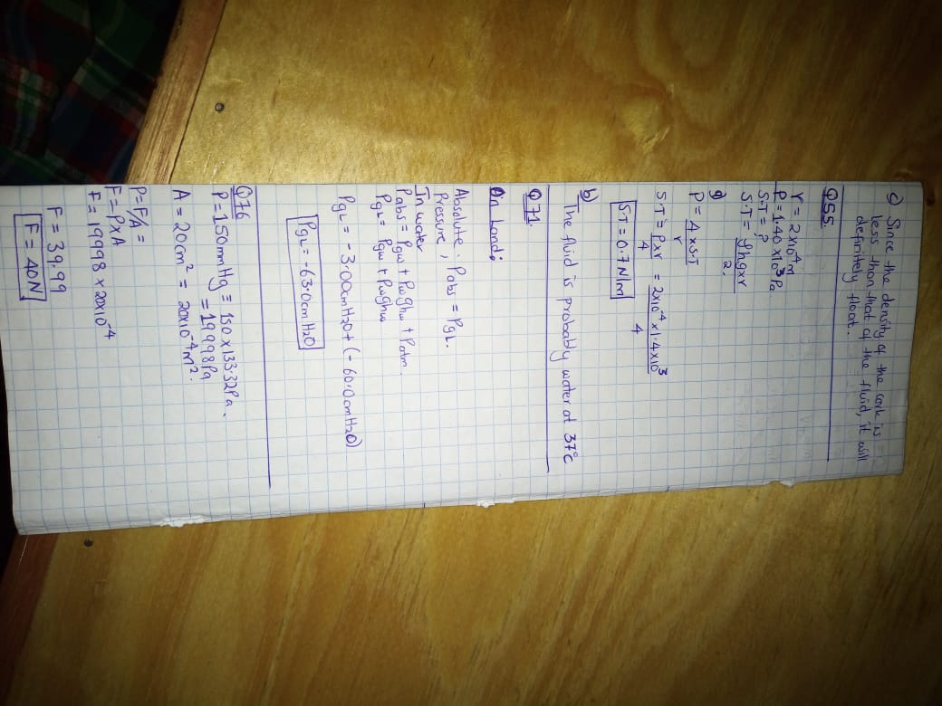

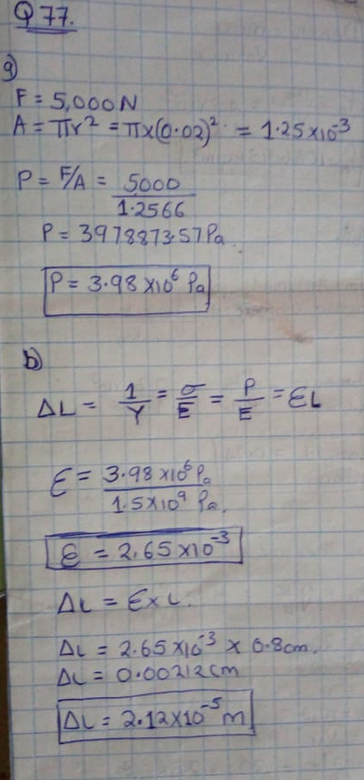
Reference
Wallace, E., & Shah, M. (2017). Introductory Physics I & II (MGA).
Levy, R. (2018). PHYS 111-007-009: Physics I.
Urone, P. P., & Hinrichs, R. (2018). College Physics: OpenStax.
Behi, M. (2018). PHYS 111-001: Physics I.

